This query performs a Cohort Retention Analysis using conditional aggregation (also known as a pivot table logic in SQL).

QUERY -;
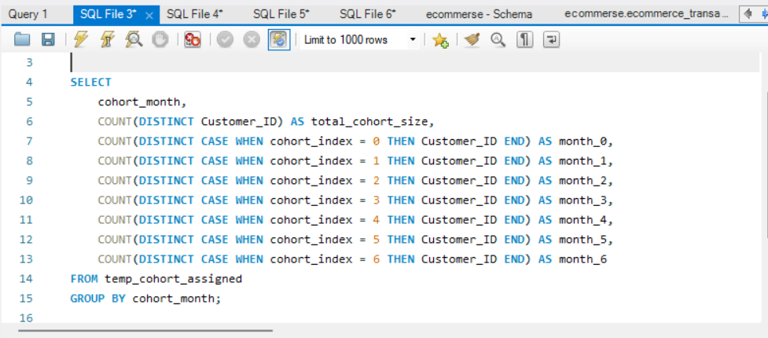

OUTPUT-;

